SD card upgrade

Matters needing attention

1、Precautions before upgrades (important):
The SD card is prohibited from taking out from the device during the upgrade process;
2、Power off not allowed during the upgrade process;
3、You shall get the properly legal upgrade bin by correct way.

Upgrade steps

Step 1: check the upgrade bin
The correct format shall be
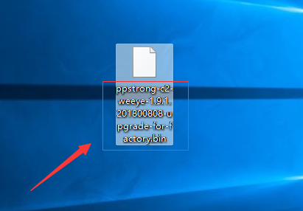
ppstrong-x2-oem-1.9.1.201800808-upgrade.bin
And, “x2” stands for device platform code, For example: c2 means IP Camera, b2 means doorbell, n2 means NVR.
“Oem” stands for “company” name
And the number “ 1.9.1.20180808” to be the vision No.
Notes: The upgrade bin connected to x2 can not use in different production line of other models.For example,if we use c2 upgrade bin on doorbell,which may cause the doorbell will not work properly.
Step 2: copy the Upgrade bin file into the SD card
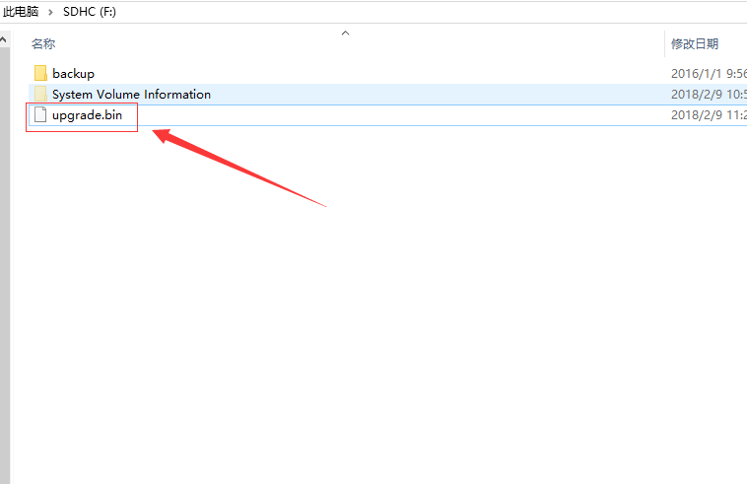
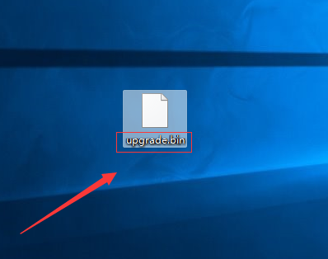
Please copy the bin file into the SD card which is properly working in device through PC. Then,change the file name which is “ppstrong-x2-oem-1.9.1.201800808-upgrade.bin” to upgrade.bin”
,after that please take out the SD card properly.

Start Device upgrading

- Please insert the SD card with the Upgrade bin file into the device which is already power connected,or,insert the SD card into the device which is power dis-connected, then get it power on,the device will start upgrading automatically.
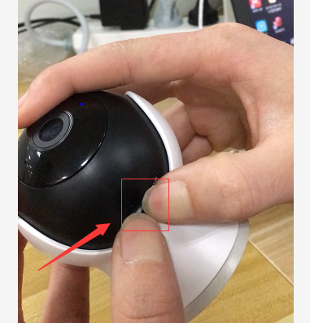
- It will continue for 3mints for upgrading process. It will re-boot after successfully upgraded and the device is running under latest version.
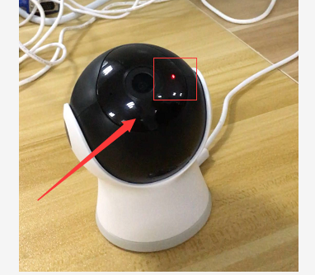
- The file name will automatically change to “upgrade_ok” after upgraded successfully.
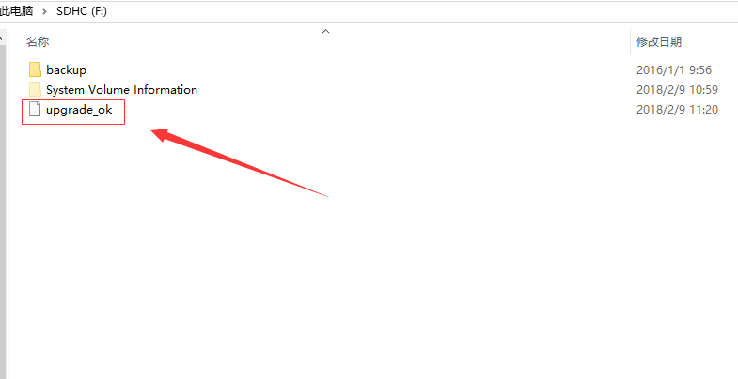

Version Check
You can check the version of the device according to the following methods:
1.you can check the version of device from APP version page.
2.You can check the name of bin file name ,if it is upgrade_ok,which means successfully.

Abnormal reminding

If the SD card taken out or power off during the process of upgrading ,the device’s function may not use properly.

